

**Hands-on Exercise No. 2**

**DigiSkills 2.0 Batch-06**

**Data Analytics & Business Intelligence**

# Problem Statement

A dashboard is a dynamic and interactive visual representation of data that combines charts, graphs, tables, and other elements to provide a comprehensive overview of key metrics and trends. It allows users to analyze and monitor data in a user-friendly format, facilitating data-driven decision-making and enhancing insights for improved business strategies. Excel's dashboard creation tools enable the efficient organization and presentation of data for effective data analytics and reporting.

# Tasks:

1. Download the dataset from the following link: <https://lms.digiskills.pk/Courses/DBI101/Downloads/ExcelSalesData_for_Dashboard.xlsx>

and load the dataset into the free online version of Microsoft Excel 365. After loading the data set, you were required to create new pivot tables for each task separately in Microsoft Excel 365.

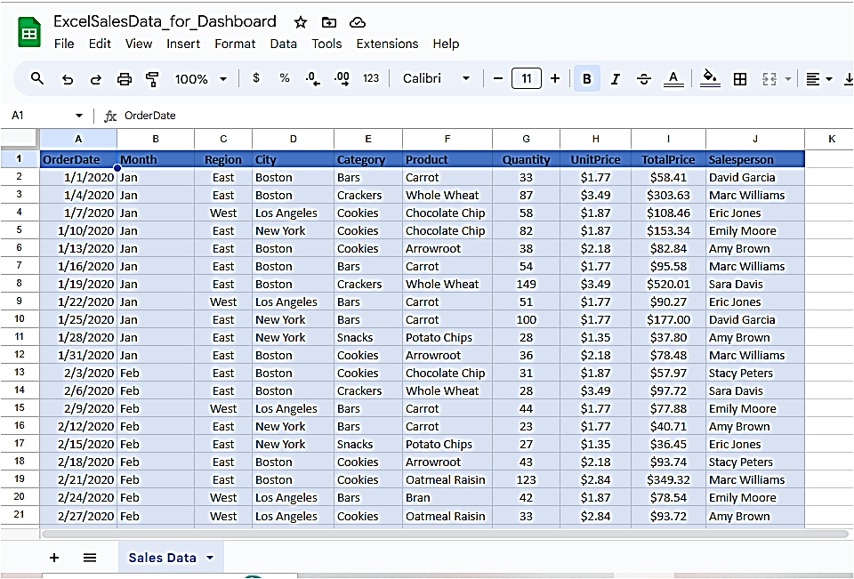

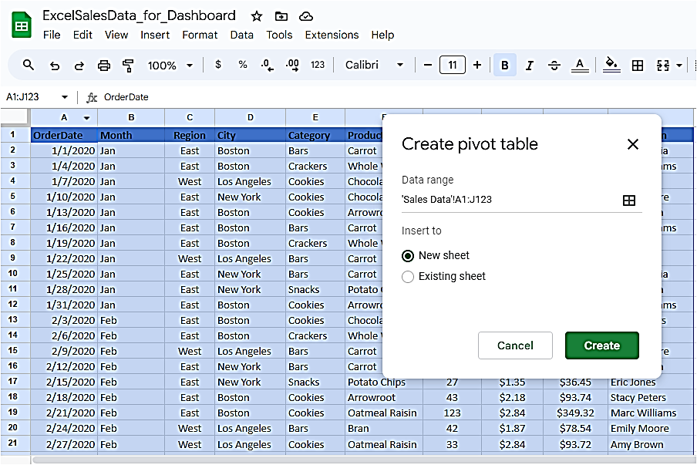

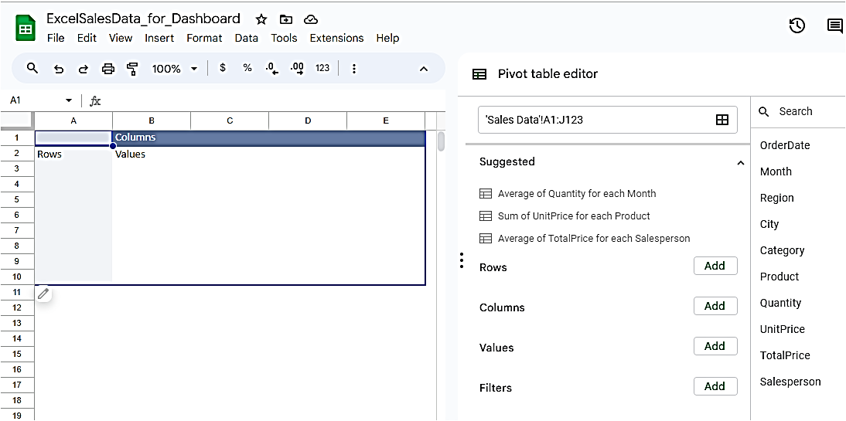

1. Create and format a line chart in Microsoft Excel to represent sales profit by month.

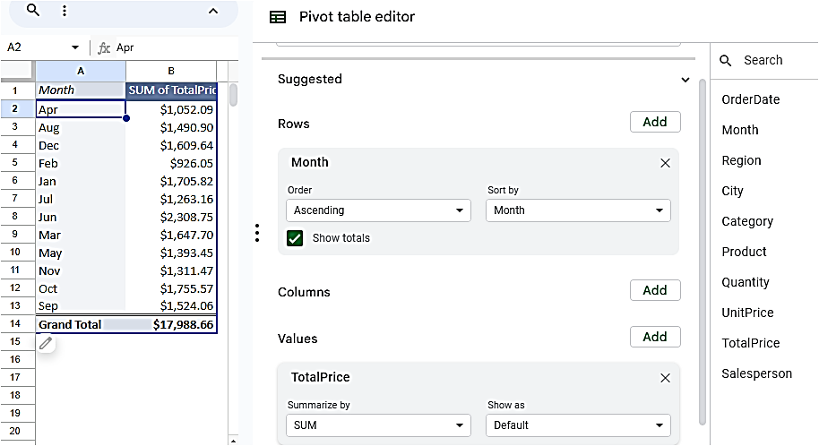

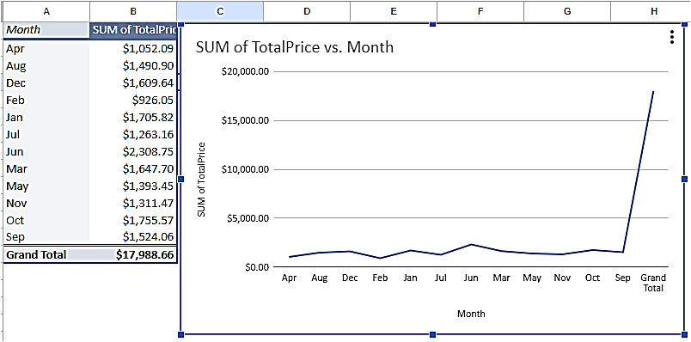

1. Create and format a bar chart in Microsoft Excel to represent sales profit by salesperson. 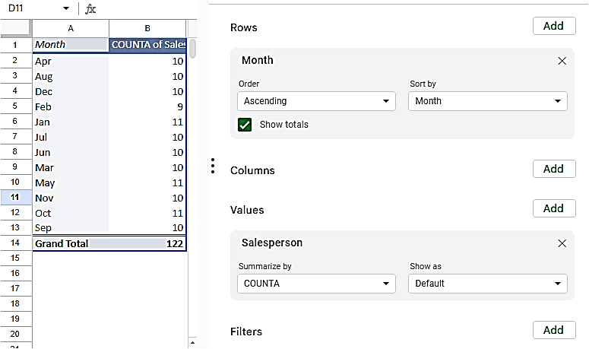

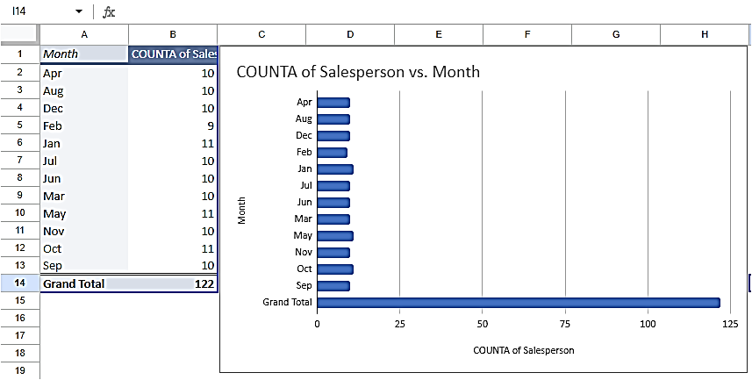

1. Create and format pie charts in Microsoft Excel to represent sales percentages by product category and city.

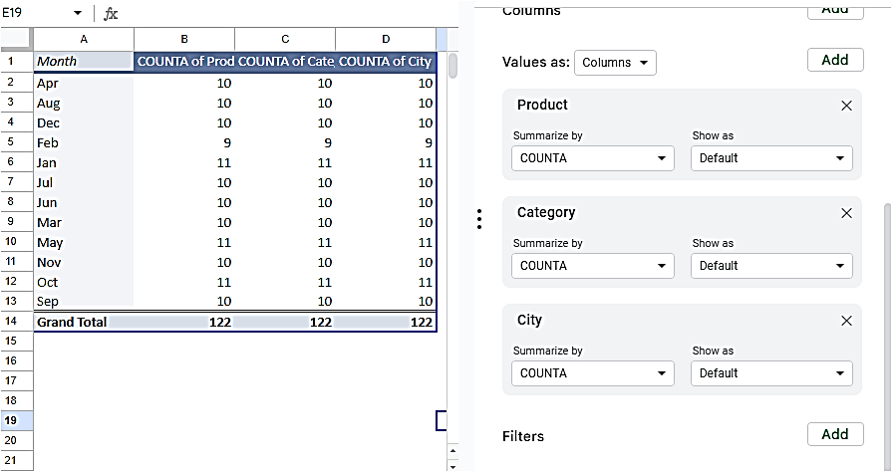

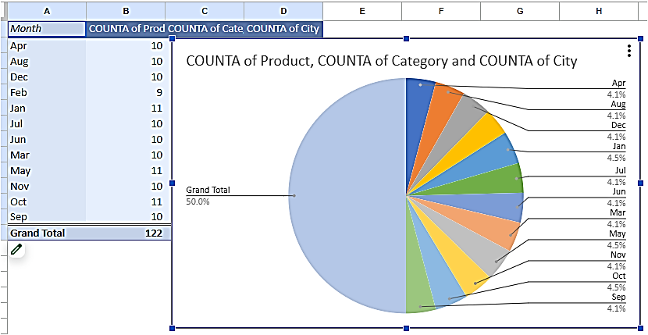

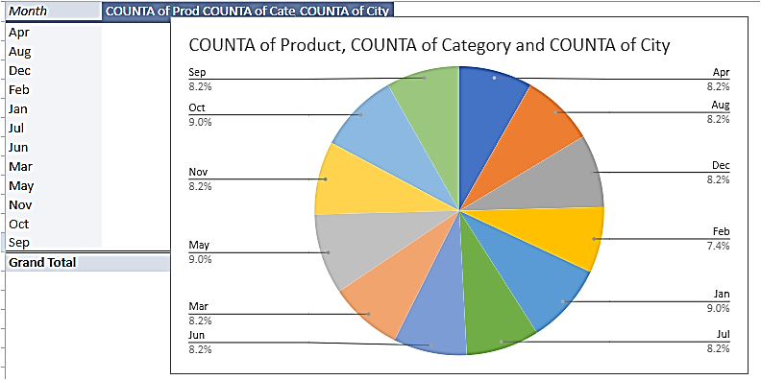

1. Create a dashboard in Microsoft Excel containing charts and tables.

